JAVA FINAL PROJECT REPORT

ITX 1300 – ROOM BOOKING SYSTEM

Fakeermahamood Zaffar – M00685151

Table of Contents

Room Booking System 2

Overview 2

Design Iteration 3

Features: 4

Password Authentication 4

Menu Interface 4

Display Rooms 5

Add Room 6

Delete Room 6

Book Room 7

Search 7

Sorting 8

View Customers 8

Add Customer 9

Prompt on closing 9

Difficulties encountered: 10

References 10

# Room Booking System

A Room Booking System (RBS) is a user friendly Java Desktop Application that allows a user to manage a real life booking system. The RBS provide features such as the booking of a room, viewing/amending records in the database.

# Overview

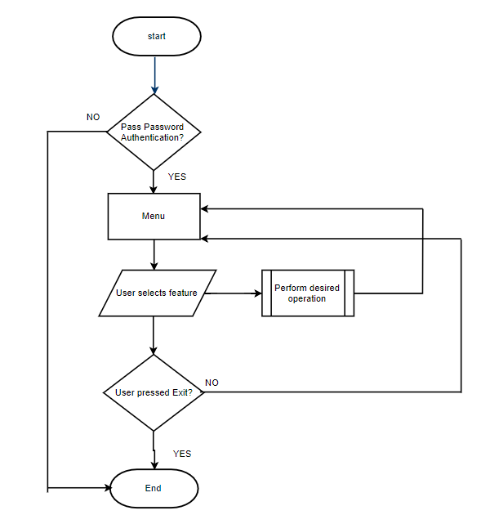

# Design Iteration

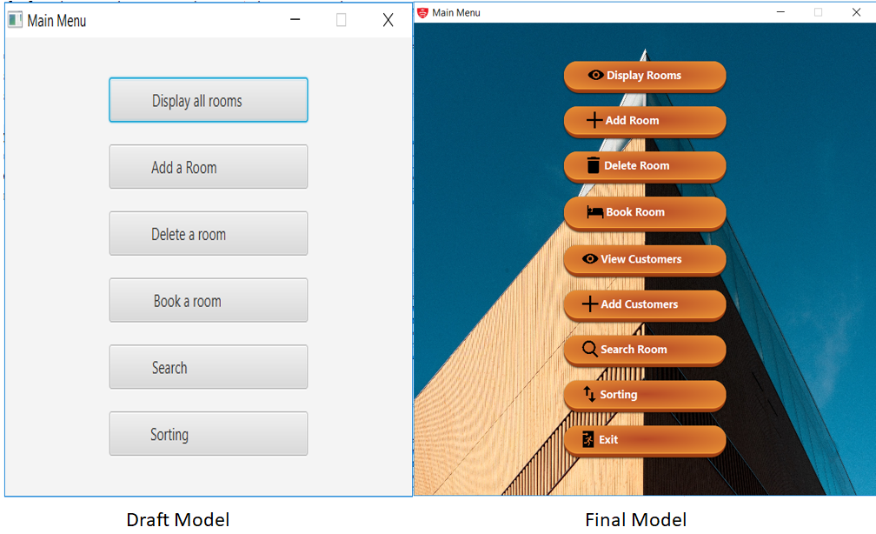

The final model is the same concept as the Draft Model. After the draft model was designed and tested, it was still missing the final touch. An interactive user friendly menu interface was of utmost importance , which led to the Final Model.

# Features:

## Password Authentication

The system will prompt the user to enter a username and a password. The user will not be able to access the system unless the correct credential has been entered.

Username : Zaffar

Password : Zaffar

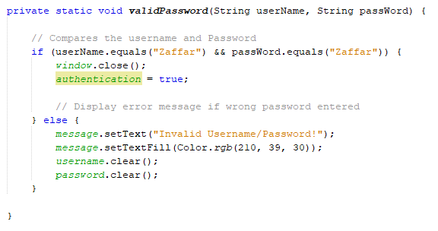

## Menu Interface

Main GUI where it allows the user to decide operation desired.

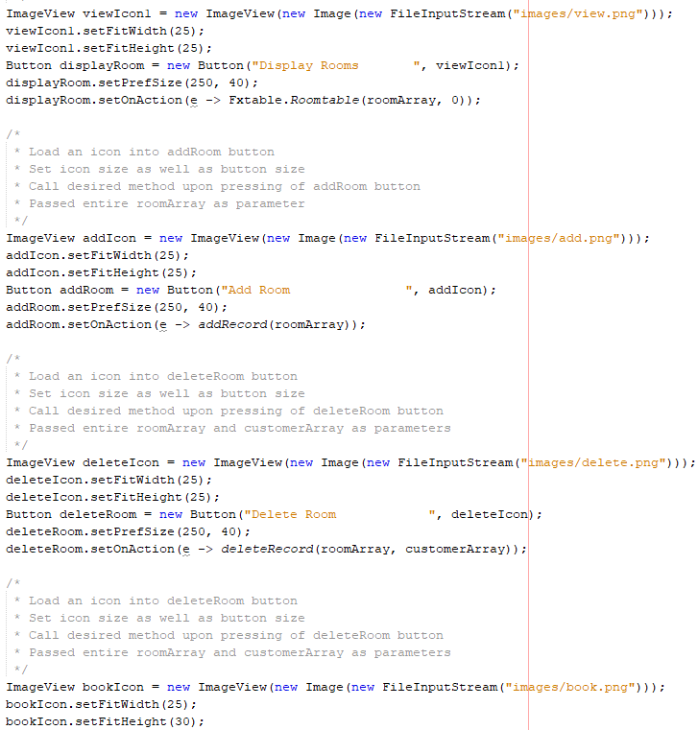

## Display Rooms

This method makes the use of javafx table to display all rooms (read from files then loaded into room array object).

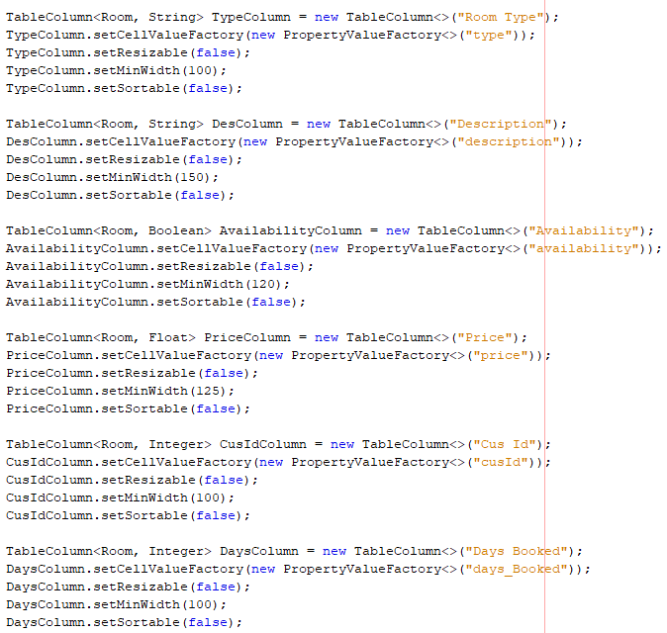

## Add Room

This feature enables the user to add a record to the room database. After all validations, the new record will be added to both array and current file. The system will automatically assign a room ID to the new record.

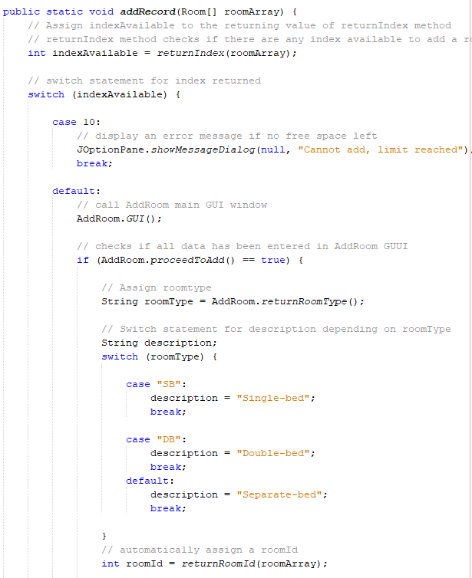

## Delete Room

This method simply deletes a room record and updates both array and file.

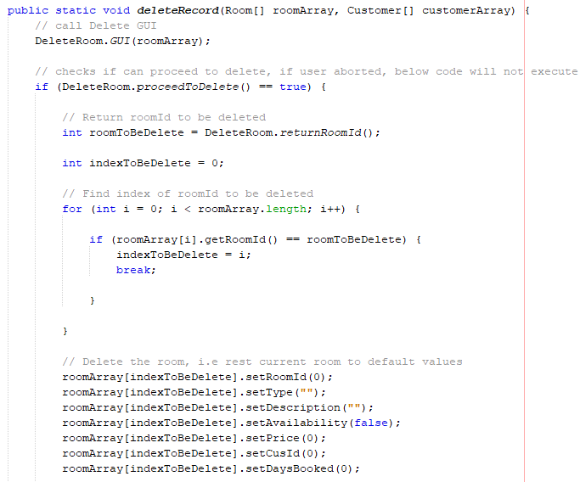

## Book Room

This method allows the booking of a room. It will display a list of rooms available and will ask for customer ID, provided that the customer’s details have already been added to the Customer database.

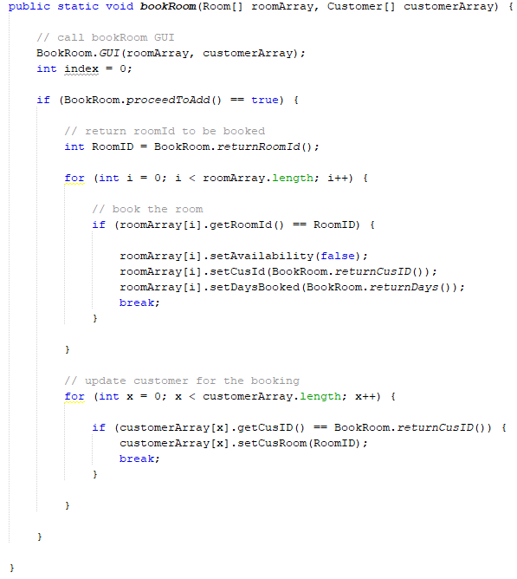

## Search

This method allows to search for any room record depending on the user choice.

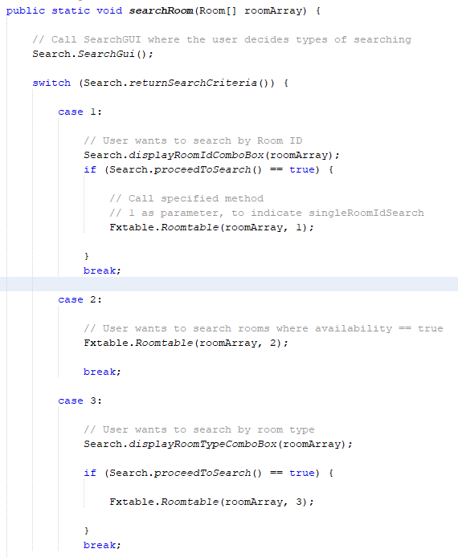

## Sorting

This method include both single sorting as well as double sorting where it arranges all data in ascending order or alphabetically.

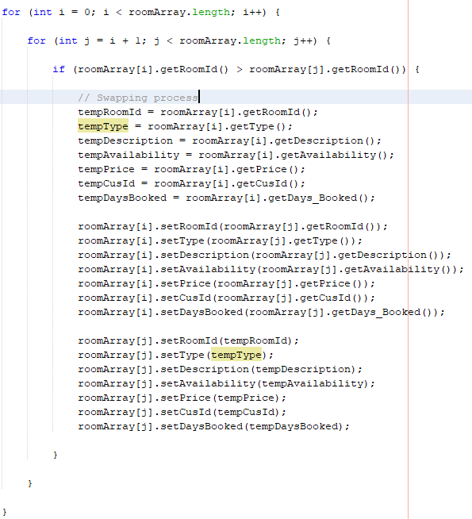

## View Customers

Similar to Display Rooms method, this method loads data from customer array into javafx table.

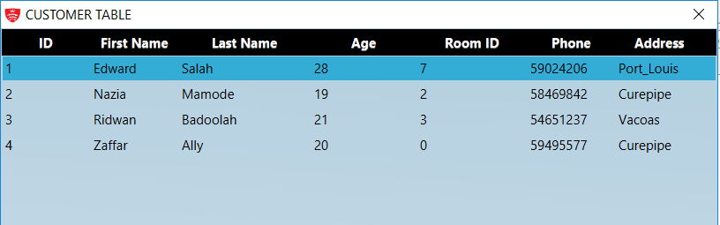

## Add Customer

This feature prompts user to enter customer details. After all validations have been met, the system will update customer array and customer file.

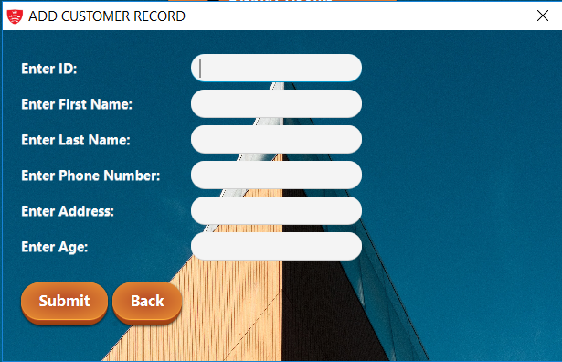

## Prompt on closing

This ensure proper closing of the system

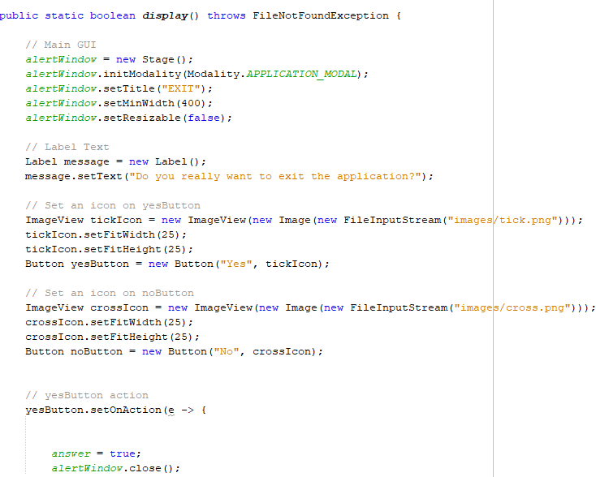

# Difficulties encountered:

* Javafx table

The use of array list is a more easy and efficient way to display the javafx table. However, since array list was not an option, I had to resort to another way to display same. (Load data from files into room array then return the array into javafx table)

* Double sorting

Since double sorting was a requirement, I faced loads of problem in implementing same.

* Cascading Style Sheet (CSS)

To makes the GUI more interactive, I had to use CSS, which I had to learn by myself.

# References

* thenewboston (2015). JavaFX Java GUI Tutorial - 1 - Creating a Basic Window. [video] Available at: https://youtu.be/FLkOX4Eez6o?list=PL6gx4Cwl9DGBzfXLWLSYVy8EbTdpGbUIG
* Oracle. (2017). Lesson: Classes and Objects (The Java™ Tutorials > Learning the Java Language). [online] Available at: https://docs.oracle.com/javase/tutorial/java/javaOO/index.html